
FATIMA JINNAH WOMEN UNIVERSITY

Submitted by: Alishba Zainab
Roll no: 23-BSE-006
Semester: VA
Submitted to: Sir Waqas

ASSIGNMENT 1
CLOUD COMPUTING

Submission Checklist:
1.Screenshot of your Gitea repository (showing README listing names & roll numbers)
2.GitHub assignment 1 repo link (with README and large files)
3.Screenshot or output of git remote -v showing both remotes
4.GitHub Pages link to your CV/portfolio

Task 1: Run Gitea in Codespace and Create an Initial Repo
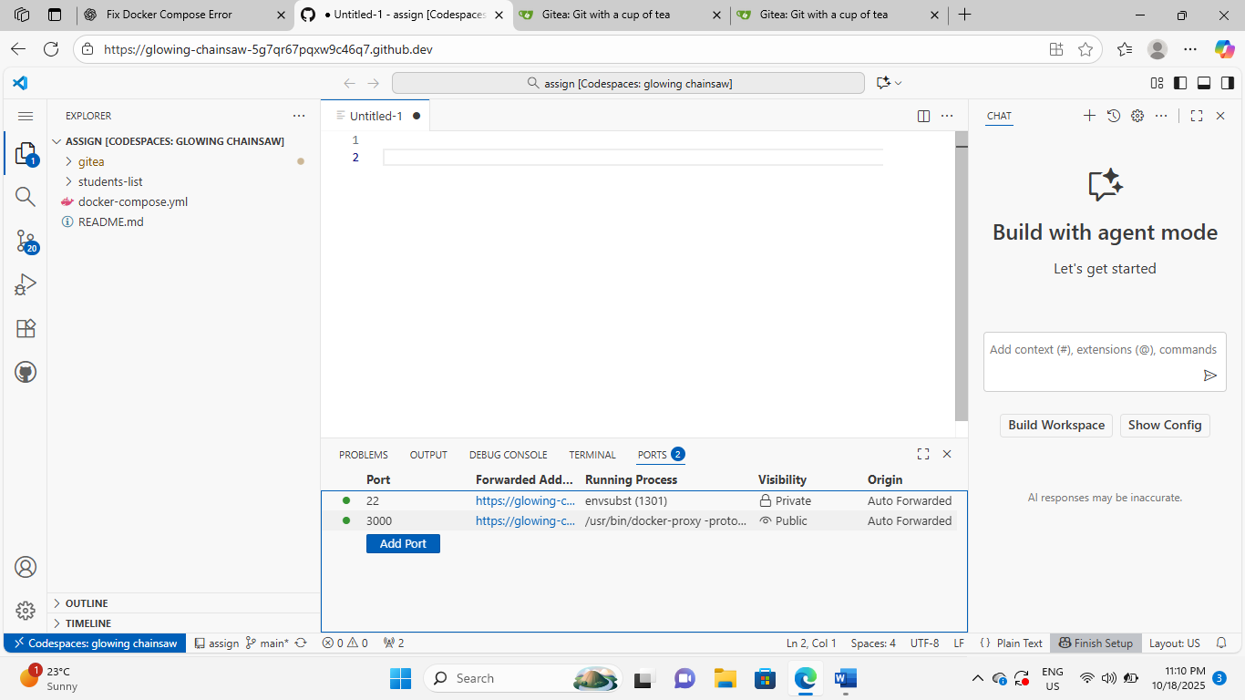
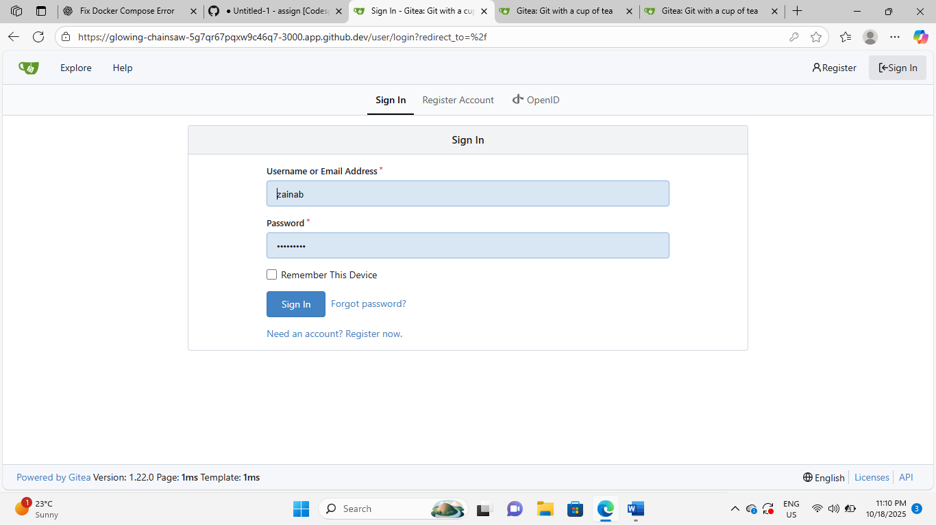

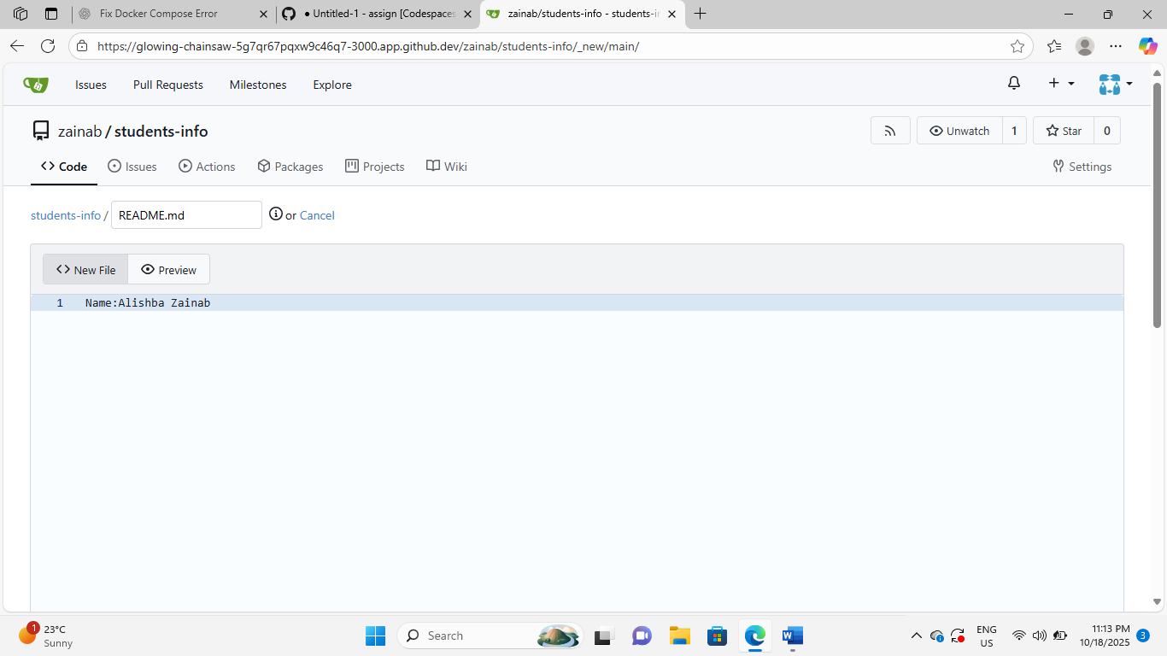
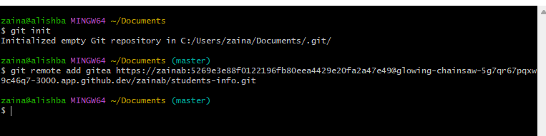
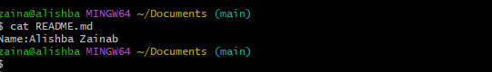
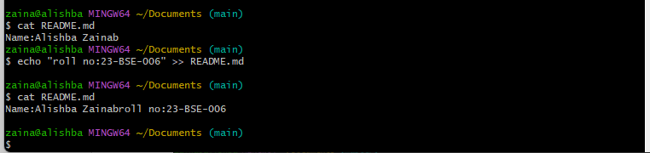

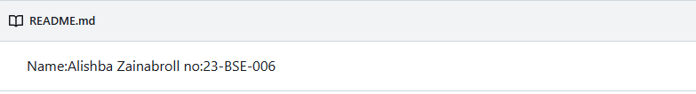

Task 2:
Mirror README.md from Gitea to GitHub
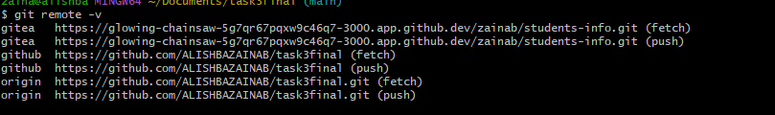

Task 3:
Use Git LFS for Large Files
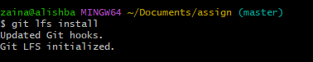
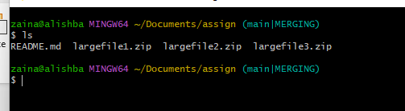

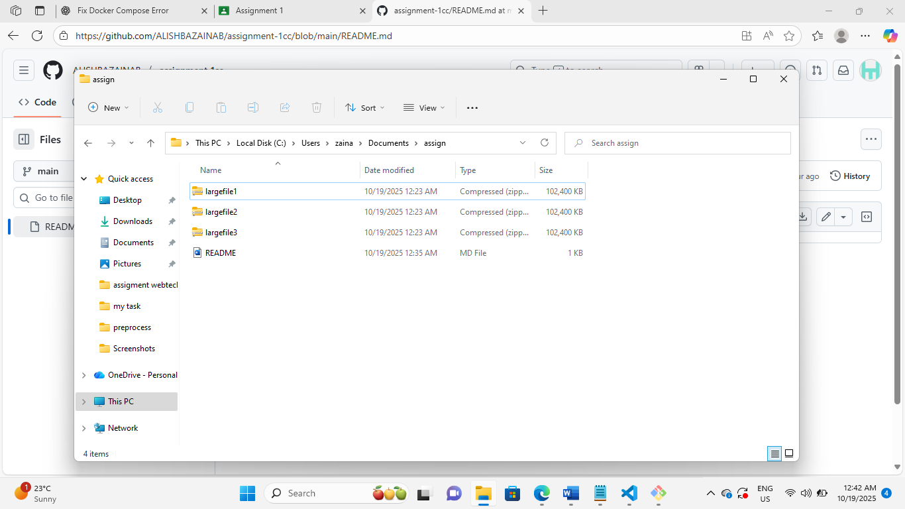
Link:
task3final/ at main · ALISHBAZAINAB/task3final
Task 4:
Create a Portfolio/CV with GitHub Pages
https://alishbazainab.github.io/alishba.github.io/

